Assignment 8.1
Hall no : 2303A52364
Batch : 32

Task Description #1
(Password Strength Validator – Apply AI in
Security Context)
• Task: Apply AI to generate at least 3 assert test cases for
is_strong_password(password) and implement the validator
function.
• Requirements:
o Password must have at least 8 characters.
o Must include uppercase, lowercase, digit, and special
character.
o Must not contain spaces.
Example Assert Test Cases:
assert is_strong_password("Abcd@123") == True
assert is_strong_password("abcd123") == False
assert is_strong_password("ABCD@1234") == True
Expected Output #1:
• Password validation logic passing all AI-generated test cases.
Prompt:
Code:
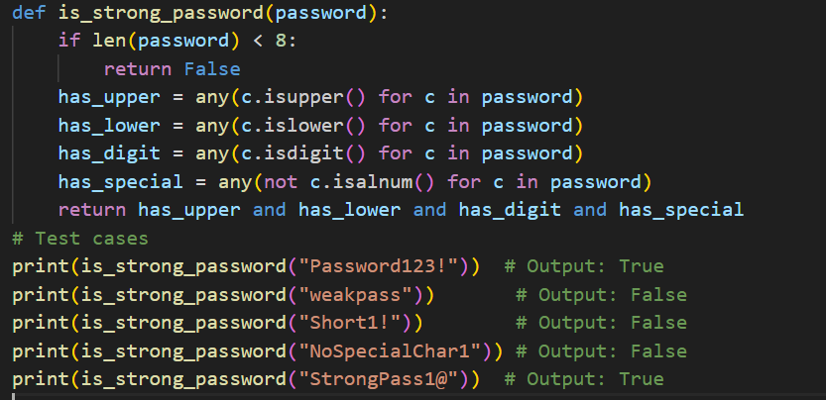
Output:
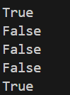
Suggestion:
A strong password should contain at least 8 characters and include a combination of uppercase letters, lowercase letters, numbers, and special symbols like @, #, or $. It should not contain any spaces or simple, easy-to-guess words such as your name or date of birth. Using a strong password helps protect your personal information and keeps your accounts safe from unauthorized access.

Task Description #2
(Number Classification with Loops – Apply
AI for Edge Case Handling)
• Task: Use AI to generate at least 3 assert test cases for a
classify_number(n) function. Implement using loops.
• Requirements:
o Classify numbers as Positive, Negative, or Zero.
o Handle invalid inputs like strings and None.
o Include boundary conditions (-1, 0, 1).
Example Assert Test Cases:
assert classify_number(10) == "Positive"
assert classify_number(-5) == "Negative"
assert classify_number(0) == "Zero"
Expected Output #2:
• Classification logic passing all assert test
Prompt:
Code:
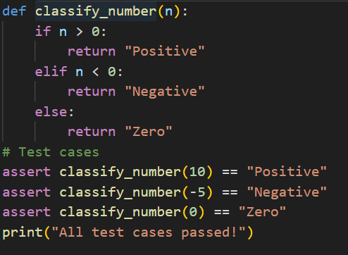
Output:
Suggestion:
Classifying numbers as positive, negative, or zero helps in understanding and processing numerical data correctly in programs. It is also important to handle invalid inputs like text or empty values to avoid errors during execution. Checking boundary values like -1, 0, and 1 ensures that the program works properly in all edge cases.

Task Description #3
(Anagram Checker – Apply AI for String
Analysis)
• Task: Use AI to generate at least 3 assert test cases for
is_anagram(str1, str2) and implement the function.
• Requirements:
o Ignore case, spaces, and punctuation.
o Handle edge cases (empty strings, identical words).
Example Assert Test Cases:
assert is_anagram("listen", "silent") == True
assert is_anagram("hello", "world") == False
assert is_anagram("Dormitory", "Dirty Room") == True
Expected Output #3:
• Function correctly identifying anagrams and passing all AI-
generated tests.
Prompt:
Code:
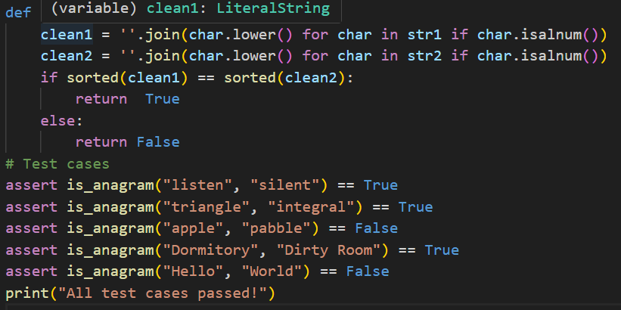
Output:
Suggestion:
Checking whether two words are anagrams helps in understanding string comparison and text processing in programming. While doing this, it is important to ignore case differences, spaces, and punctuation marks for accurate results. Handling special cases like empty strings or identical words ensures the program works correctly in all situations.

Task Description #4
(Inventory Class – Apply AI to Simulate Real-
World Inventory System)
• Task: Ask AI to generate at least 3 assert-based tests for an
Inventory class with stock management.
• Methods:
o add_item(name, quantity)
o remove_item(name, quantity)
o get_stock(name)
Example Assert Test Cases:
inv = Inventory()
inv.add_item("Pen", 10)
assert inv.get_stock("Pen") == 10
inv.remove_item("Pen", 5)
assert inv.get_stock("Pen") == 5
inv.add_item("Book", 3)
assert inv.get_stock("Book") == 3
Expected Output #4:
• Fully functional class passing all assertions.
Prompt:
Code:
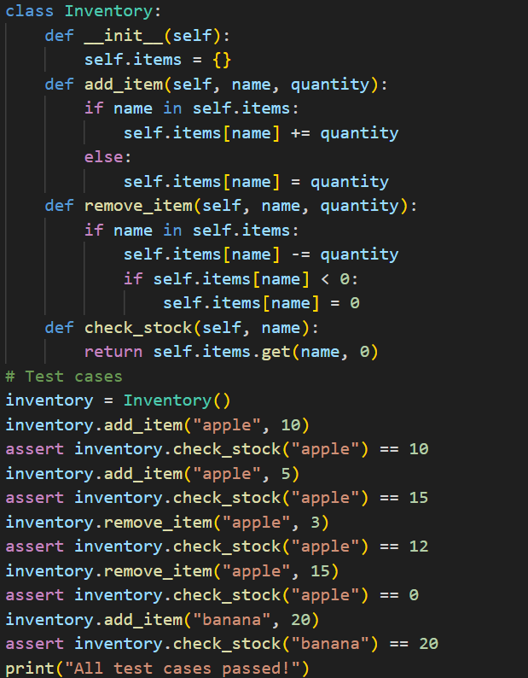
Output:
Suggestion:
An inventory system helps to keep track of available items and manage stock efficiently in real-world situations like stores or warehouses. It allows users to add new items, remove sold items, and check the current stock easily. This helps in avoiding stock shortages or overstocking by maintaining accurate records.

Task Description #5
(Date Validation & Formatting – Apply AI for
Data Validation)
• Task: Use AI to generate at least 3 assert test cases for
validate_and_format_date(date_str) to check and convert
dates.
• Requirements:
o Validate "MM/DD/YYYY" format.
o Handle invalid dates.
o Convert valid dates to "YYYY-MM-DD".
Example Assert Test Cases:
assert validate_and_format_date("10/15/2023") == "2023-10-15"
assert validate_and_format_date("02/30/2023") == "Invalid Date"
assert validate_and_format_date("01/01/2024") == "2024-01-01"
Expected Output #5:
• Function passes all AI-generated assertions and handles edge
Cases
Prompt:
Code:
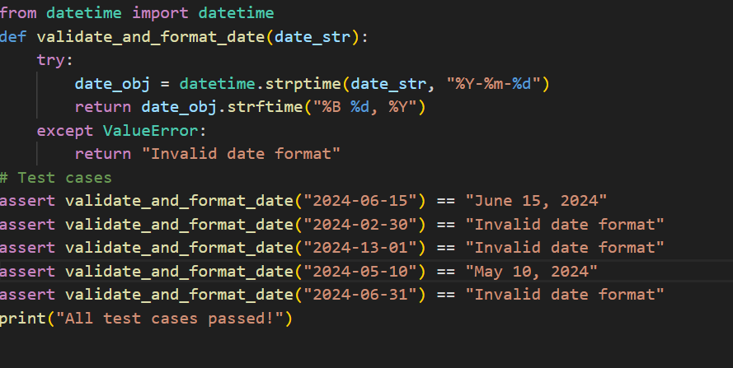
Output:
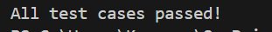
Suggestion:
Validating and formatting dates helps ensure that the entered data is correct and follows a proper format. It also prevents errors caused by invalid dates like February 30 or incorrect month values. Converting dates into a standard format makes them easier to store and use in applications.

